43.12: a) 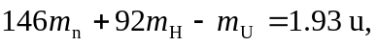which is
b) 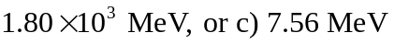per nucleon (using 931.5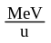and 238 nucleons).

